Practical lesson 14 : Microbiological diagnosis of infections caused by pathogenic anaerobes (genus Clostridium and Bacteroides) and zoonotic infections (genus Brucella, Bacillus, Yersinia, Francisella).
CLOSTRİDİUM
There are four medically important species: Clostridium tetani, Clostridium botulinum, Clostridium perfringens (which causes either gas gangrene or food poisoning), and Clostridium difficile. All clostridia are anaerobic, spore-forming, gram-positive rods.
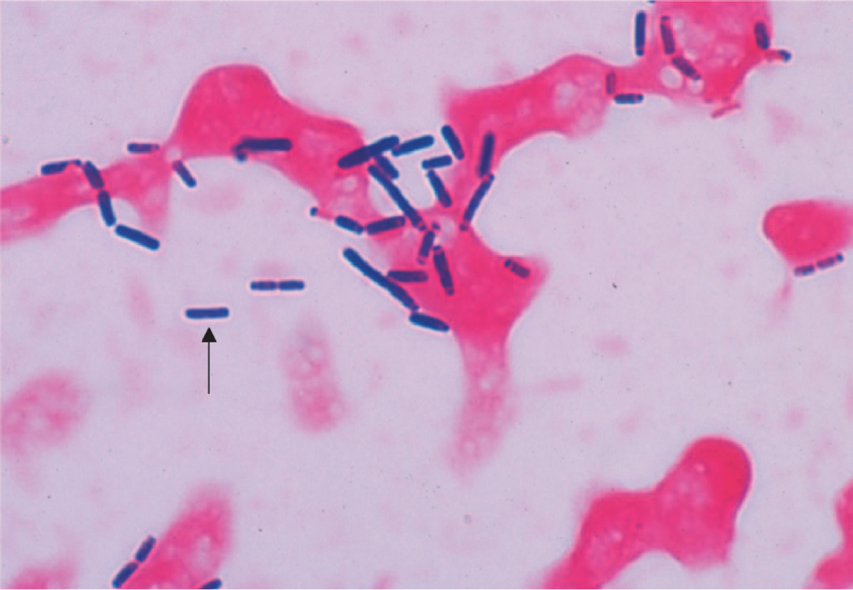
Clostridium perfringens—Gram stain. Arrow points to a large gram-positive rod.

1. Clostridium tetani
Disease
Clostridium tetani causes tetanus .
Clinical Findings
Tetanus is characterized by strong muscle spasms (spastic paralysis, tetany). Specific clinical features include lockjaw (trismus) due to rigid contraction of the jaw muscles, which prevents the mouth from opening; a characteristic grimace known as risus sardonicus; and exaggerated reflexes. Opisthotonos, a pronounced arching of the back due to spasm of the strong extensor muscles of the back, is often seen . Respiratory failure ensues. A high mortality rate is associated with this disease. Note that in tetanus, spastic paralysis (strong muscle contractions) occurs, whereas in botulism, flaccid paralysis (weak or absent muscle contractions) occurs.
Laboratory Diagnosis
There is no microbiologic or serologic diagnosis. Organisms are rarely isolated from the wound site. Clostridium tetani produces a terminal spore (i.e., a spore at the end of the rod). This gives the organism the characteristic appearance of a “tennis racket.”
Treatment
Tetanus immune globulin (tetanus antitoxin) is used to neutralize the toxin. The role of antibiotics is uncertain. If antibiotics are used, either metronidazole or penicillin G can be given. An adequate airway must be maintained and respiratory support given. Benzodiazepines (e.g., diazepam [Valium]) should be given to prevent spasms.

Prevention
Tetanus is prevented by immunization with tetanus toxoid (formaldehyde-treated toxin) in childhood and every 10 years thereafter. Tetanus toxoid is usually given to children in combination with diphtheria toxoid and the acellular pertussis vaccine (DTaP).
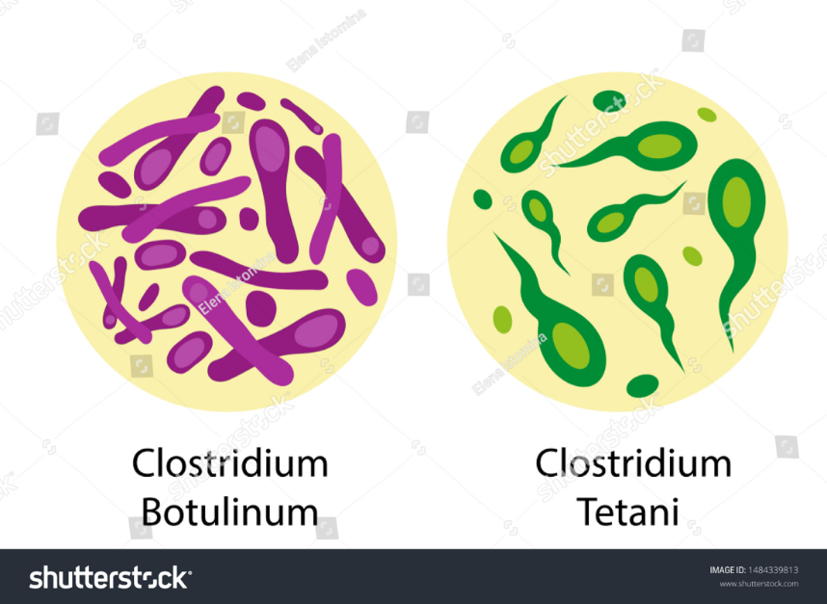

2. Clostridium botulinum
Disease
Clostridium botulinum causes botulism.
Clinical Findings
Descending weakness and paralysis, including diplopia, dysphagia, and respiratory muscle failure, are seen. No
fever is present. In contrast, Guillain-Barré syndrome is an ascending paralysis . Two special clinical forms occur: (1) wound botulism, in which spores contaminate a wound, germinate, and produce toxin at the site; and (2) infant botulism, in which the organisms grow in the gut and produce the toxin there. Ingestion of honey containing the organism is implicated in transmission of infant botulism. Affected infants develop weakness or paralysis and may need respiratory support but usually recover spontaneously. In the United States, infant botulism accounts for about half of the cases of botulism, and wound botulism is associated with drug abuse, especially skin-popping with black tar heroin.
Laboratory Diagnosis
The organism is usually not cultured. Botulinum toxin is demonstrable in uneaten food and the patient’s
serum by mouse protection tests. Mice are inoculated with a sample of the clinical specimen and will die unless protected by antitoxin. Enzyme-linked immunoassay (EIA) tests are also used to detect the toxin and polymerase-chain reaction (PCR) tests are being developed.
Treatment
The heptavalent antitoxin containing all seven types (A to G) is preferred to the trivalent antitoxin containing types A, B, and E. Respiratory support is provided as well. The antitoxin is made in horses and serum sickness may occur. A bivalent antitoxin (types A and B) purified from the plasma of humans immunized with botulinum toxoid is available for the treatment of infant botulism.
Prevention
Proper sterilization of all canned and vacuum-packed foods is essential. Food must be adequately cooked to inactivate the toxin. Swollen cans must be discarded (clostridial proteolytic enzymes form gas, which swells cans).

3. Clostridium perfringens
Clostridium perfringens causes two distinct diseases, gas gangrene and food poisoning, depending on the route of entry into the body.
Disease: Gas Gangrene
Gas gangrene (myonecrosis, necrotizing fasciitis) is one of the two diseases caused by C. perfringens .Gas gangrene is also caused by other histotoxic clostridia such as Clostridium histolyticum, Clostridium septicum, Clostridium novyi, and Clostridium sordellii. (C. Sordellii also causes toxic shock syndrome in postpartum and postabortion women.)
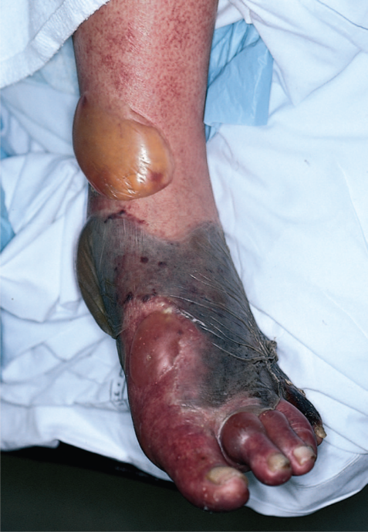
Gas gangrene. Note large area of necrosis on lateral aspect of foot. Necrosis is mainly caused by lecithinase produced by Clostridium perfringens. Gas in tissue is a feature of gangrene produced by these anaerobic bacteria. A large gas- and fluid-filled bulla is seen near the ankle.

Clinical Findings
Pain, edema, cellulitis, and gangrene (necrosis) occur in the wound area. If crepitus is palpated in the
affected tissue, it indicates gas in the tissue. This gas is typically hydrogen produced by the anaerobic bacteria. Hemolysis and jaundice are common, as are blood-tinged exudates. Shock and death can ensue. Mortality rates are high.
Laboratory Diagnosis
Smears of tissue and exudate samples show large grampositive rods. Spores are not usually seen because they are formed primarily under nutritionally deficient conditions. The organisms are cultured anaerobically and then identified by sugar fermentation reactions and organic acid production. Clostridium perfringens colonies exhibit a double zone of hemolysis on blood agar. The colonies also produce a precipitate in egg yolk agar caused by the action of its lecithinase.Serologic tests are not useful.
Treatment
Penicillin G is the antibiotic of choice. Wounds should be debrided.
Prevention
Wounds should be cleansed and debrided. Penicillin may be given for prophylaxis. There is no vaccine.

Disease: Food Poisoning
Food poisoning is the second disease caused by C. perfringens.
Transmission
Spores are located in soil and can contaminate food. The heat-resistant spores survive cooking and germinate. The organisms grow to large numbers in reheated foods, especially meat dishes.
Pathogenesis
Clostridium perfringens is a member of the normal flora in the colon but not in the small bowel, where the enterotoxin acts to cause diarrhea. The mode of action of the enterotoxin is the same as that of the enterotoxin of Staphylococcus aureus (i.e., it acts as a superantigen).
Clinical Findings
The disease has an 8- to 16-hour incubation period and is characterized by watery diarrhea with cramps and little vomiting. It resolves in 24 hours.
Laboratory Diagnosis
This is not usually done. There is no assay for the toxin. Large numbers of the organisms can be isolated from uneaten food.
Treatment
Symptomatic treatment is given; no antimicrobial drugs are administered.
Prevention
There are no specific preventive measures. Food should be adequately cooked to kill the organism.

4. Clostridium difficile
Disease
Clostridium difficile causes antibiotic-associated pseudomembranous colitis . Clostridium difficile is the most common nosocomial (hospital-acquired) cause of diarrhea. It is the leading infectious cause of gastrointestinal-associated deaths.
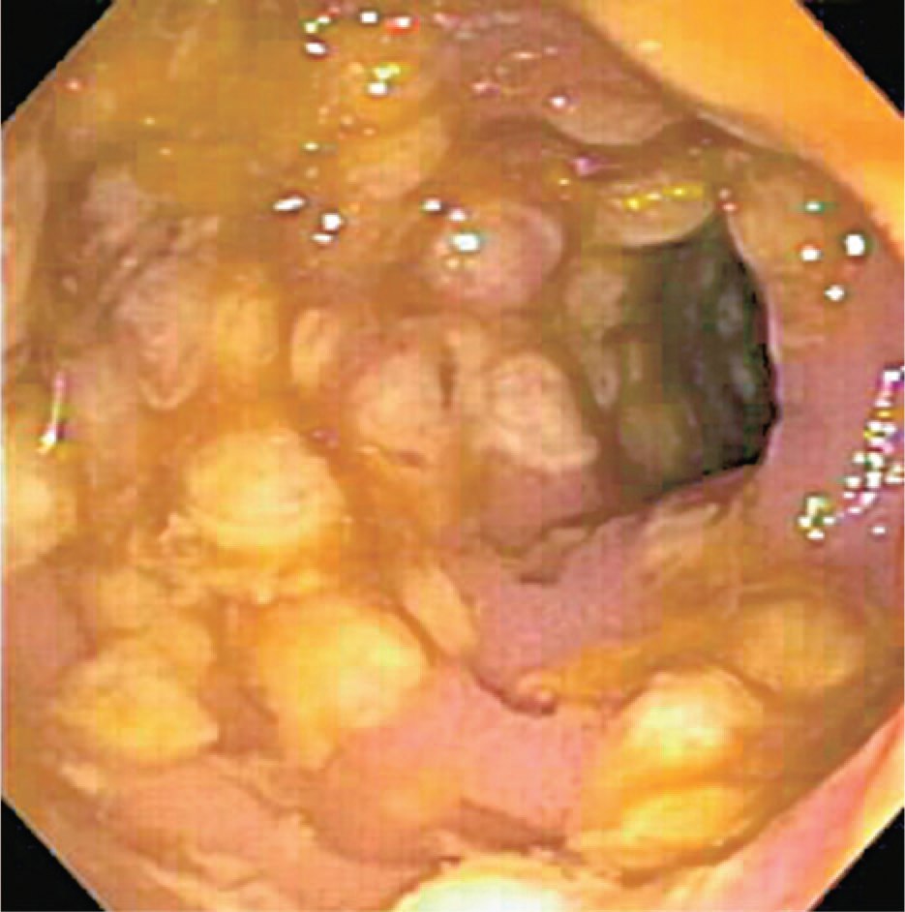
Pseudomembranous colitis. Note yellowish plaquelike lesions in colon. Caused by an exotoxin produced by Clostridium difficile that inhibits a signal transduction protein, leading to death of enterocytes

Laboratory Diagnosis
The presence of exotoxins in the filtrate of a patient’s stool specimen is the basis of the laboratory diagnosis. It is insufficient to culture the stool for the presence of C. difficile because people can be colonized by the organism and not have disease. There are two types of tests used to make the laboratory diagnosis. One detects the exotoxin itself and the other detects the genes that encode the exotoxin. To detect the exotoxin itself, an ELISA test employing antibody to the exotoxin is used. To detect the genes that encode the exotoxin, a PCR assay to determine the presence of the toxin gene DNA is used. The DNA-based test has greater sensitivity and specificity than the ELISA test.

BACTEROIDES & PREVOTELLA
Diseases
Members of the genus Bacteroides are the most common cause of serious anaerobic infections (e.g., sepsis, peritonitis, and abscesses). Bacteroides fragilis is the most frequent pathogen. Prevotella melaninogenica is also an important pathogen. It was formerly known as Bacteroides melaninogenicus, and both names are still encountered.
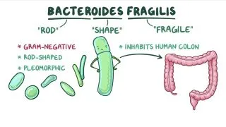
Important Properties
Bacteroides and Prevotella organisms are anaerobic, non– spore-forming, gram-negative rods. Of the many species of Bacteroides, two are human pathogens: B. fragilis7 and Bacteroides corrodens. Members of the B. fragilis group are the predominant organisms in the human colon, numbering approximately 1011/g of feces, and are found in the vagina of approximately 60% of women. Prevotella melaninogenica and B. corrodens occur primarily in the oral cavity.
Laboratory Diagnosis
Bacteroides species can be isolated anaerobically on blood agar plates containing kanamycin and vancomycin to inhibit unwanted organisms. They are identified by biochemical reactions (e.g., sugar fermentations) and by production of certain organic acids (e.g., formic, acetic, and propionic acids), which are detected by gas chromatography. Prevotella melaninogenica produces characteristic black colonies.

BRUCELLA
Disease
Brucella species cause brucellosis (undulant fever).
Important Properties
Brucellae are small gram-negative rods without a capsule.The three major human pathogens and their animal reservoirs are Brucella melitensis (goats and sheep), Brucella abortus (cattle), and Brucella suis (pigs).
Pathogenesis & Epidemiology
The organisms enter the body either by ingestion of contaminated milk products or through the skin by direct contact in an occupational setting such as an abattoir. They localize in the reticuloendothelial system, namely, the lymph nodes, liver, spleen, and bone marrow. Many organisms are killed by macrophages, but some survive within these cells, where they are protected from antibody. The host response is granulomatous, with lymphocytes and epithelioid giant cells, which can progress to form focal abscesses. The mechanism of pathogenesis of these organisms is not well defined, except that endotoxin is involved. No exotoxins are produced.
Laboratory Diagnosis
Recovery of the organism requires the use of enriched culture media and incubation in 10% CO2. The organisms can be presumptively identified by using a slide agglutination test with Brucella antiserum, and the species can be identified by biochemical tests. If organisms are not isolated, analysis of a serum sample from the patient for a rise in antibody titer to Brucella can be used to make a diagnosis. In the absence of an acute-phase serum specimen, a titer of at least 1:160 in the convalescent-phase serum sample is diagnostic.
BACILLUS
There are two medically important Bacillus species: Bacillus anthracis and Bacillus cereus.

1. Bacillus anthracis
Disease
Bacillus anthracis causes anthrax , which is common in animals but rare in humans. Human disease occurs in three main forms: cutaneous, pulmonary (inhalation), and gastrointestinal. In 2001, an outbreak of both inhalation and cutaneous anthrax occurred in the United States. The outbreak was caused by sending spores of the organism through the mail. There were 18 cases, causing 5 deaths in this outbreak.
Laboratory Diagnosis
Smears show large, gram-positive rods in chains . Spores are usually not seen in smears of exudate because spores form when nutrients are insufficient, and nutrients are plentiful in infected tissue. Nonhemolytic colonies form on blood agar aerobically. In case of a bioterror attack, rapid diagnosis can be performed in special laboratories using polymerase chain reaction (PCR)– based assays. Another rapid diagnostic procedure is the direct fluorescent antibody test that detects antigens of the organism in the lesion. Serologic tests, such as an enzyme-linked immunosorbent assay (ELISA) test for antibodies, require acute and convalescent serum samples and can only be used to make a diagnosis retrospectively.
2. Bacillus cereus
Disease
Bacillus cereus causes food poisoning.
Transmission
Spores on grains such as rice survive steaming and rapid frying. The spores germinate when rice is kept warm for many hours (e.g., reheated fried rice). The portal of entry is the gastrointestinal tract.
Pathogenesis
Bacillus cereus produces two enterotoxins. The mode of action of one of the enterotoxins is the same as that of cholera toxin (i.e., it adds adenosine diphosphate ribose, a process called ADP-ribosylation, to a G protein, which stimulates adenylate cyclase and leads to an increased concentration of cyclic AMP within the enterocyte). The mode of action of the other enterotoxin resembles that of staphylococcal enterotoxin (i.e., it is a superantigen).
Laboratory Diagnosis
This is not usually done.
LISTERIA
Diseases
Listeria monocytogenes causes meningitis and sepsis in newborns, pregnant women, and immunosuppressed adults. It also causes outbreaks of febrile gastroenteritis. It is a major cause of concern for the food industry.
Important Properties
Listeria monocytogenes is a small gram-positive rod arranged in V- or L-shaped formations similar to corynebacteria. The organism exhibits an unusual tumbling movement that distinguishes it from the corynebacteria, which are nonmotile. Colonies on a blood agar plate produce a narrow zone of β-hemolysis that resembles the hemolysis of some streptococci. Listeria grows well at cold temperatures, so storage of contaminated food in the refrigerator can increase the risk of gastroenteritis. This paradoxical growth in the cold is called “cold enhancement.”
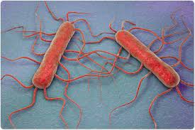
Laboratory Diagnosis
Laboratory diagnosis is made primarily by Gram stain and culture. The appearance of gram-positive rods resembling diphtheroids and the formation of small, gray colonies with a narrow zone of β-hemolysis on a blood agar plate suggest the presence of Listeria. The isolation of Listeria is confirmed by the presence of motile organisms, which differentiate them from the nonmotile corynebacteria. Identification of the organism as L. monocytogenes is made by sugar fermentation tests.
YERSINIA
Disease
Yersinia pestis is the cause of plague, also known as the black death, the scourge of the Middle Ages. It is also a contemporary disease, occurring in the western United States and in many other countries around the world.
Important Properties
Yersinia pestis is a small gram-negative rod that exhibits bipolar staining (i.e., it resembles a safety pin, with a central clear area). Freshly isolated organisms possess a capsule composed of a polysaccharide–protein complex. The capsule can be lost with passage in the laboratory; loss of the capsule is accompanied by a loss of virulence. It is one of the most virulent bacteria known and has a strikingly low ID50 (i.e., 1–10 organisms are capable of causing disease).
Laboratory Diagnosis
Smear and culture of blood or pus from the bubo is the best diagnostic procedure. Great care must be taken by the physician during aspiration of the pus and by laboratory workers doing the culture not to create an aerosol that might transmit the infection. Giemsa or Wayson stain reveals the typical safety-pin appearance of the organism better than does Gram stain. Fluorescent-antibody staining can be used to identify the organism in tissues. A rise in antibody titer to the envelope antigen can be useful retrospectively.
Treatment
The treatment of choice is a combination of streptomycin and a tetracycline such as doxycycline, although streptomycin alone can be used. Levofloxacin can also be used. There is no significant antibiotic resistance. In view of the rapid progression of the disease, treatment should not wait for the results of the bacteriologic culture. Incision and drainage of the buboes are not usually necessary.
Prevention
Prevention of plague involves controlling the spread of rats in urban areas, preventing rats from entering the country by ship or airplane, and avoiding both flea bites and contact with dead wild rodents. A patient with plague must be placed in strict isolation (quarantine) for 72 hours after antibiotic therapy is started. Only close contacts need to receive prophylactic tetracycline, but all contacts should be observed for fever. Reporting a case of plague to the public health authorities is mandatory. A vaccine consisting of formalin-killed organisms provides partial protection against bubonic but not pneumonic Plague.
FRANCISELLA
Disease
Francisella tularensis causes tularemia.
Important Properties
Francisella tularensis is a small, pleomorphic gram-negative rod. It has a single serologic type. There are two biotypes, A and B, which are distinguished primarily on their virulence and epidemiology. Type A is more virulent and found primarily in the United States, whereas type B is less virulent and found primarily in Europe
Laboratory Diagnosis
Attempts to culture the organism in the laboratory are rarely undertaken, because there is a high risk to laboratory workers of infection by inhalation, and the special cysteinecontaining medium required for growth is not usually available. The most frequently used diagnostic method is the agglutination test with acute- and convalescent-phase serum samples. Fluorescent-antibody staining of infected tissue can be used if available.
Treatment
Streptomycin is the drug of choice. There is no significant antibiotic resistance.
Prevention
Prevention involves avoiding both being bitten by ticks and handling wild animals. There is a live, attenuated bacterial vaccine that is given only to persons, such as fur trappers, whose occupation brings them into close contact with wild Animals.

